Regular Expressions
A regular expression is a string that contains special symbol and characters to find and extract the information needed by us from the given data. A regular expression helps us to search information, match, find and split information as per our requirements. It is also called simply regex.
Python provides re module that stands for regular expressions. This module contains methods like compile (), search (), findall (), split (), etc. which are used in finding the information in available data. So, when we write regular expression, we should import re module as:
import re
Regular expressions are nothing but strings containing characters and special symbols. A simple regular expression may look like this:
reg = r’m\w\w’
In preceding line the string is prefixed with ‘r’ to represent that it is a raw string. Generally, we write regular expression as raw strings. In regular expressions when ‘\n’ is used, it does not mean to throw the string into new line. There ‘\n’ has a different meaning and it should not interpreted as new line. For this purpose, we should take this as a ‘raw’ string. This is done by doing ‘r’ before the string. In above expression ‘m\w\w’ is to represent that it is a string. The first ‘m’ represents that the words starting with ‘m’ should be matched. The next character ‘\w’ represents any one character in A to Z, a to z and 0 to 9. Since we used two ‘\w’ characters, they represent any two characters after ‘m’. So, this regular expression represents words or strings having three characters and with ‘m’ as first character. The next two characters can be any alphanumeric.
The next step is to compile this expression using compile () method of ‘re’ module as:
Prog = re.compile(r’m\w\w’)
Now, prog represents an object that contains the regular expression. The next step is to run this expression on a string ‘str’ using the search() method or match () method as:
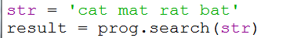
The result is stored in ‘result’ object and we can display it by calling the group() method on the object as:
Output:
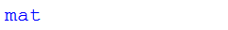
Following figure shows how to execute the regular expressions in the Python IDLE window:
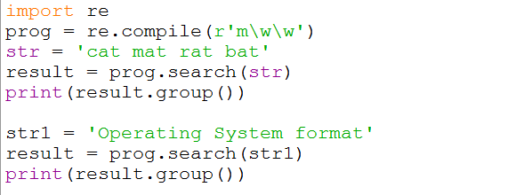
OUTPUT:
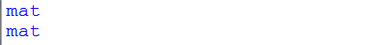
Program: A Python program to create a regular expression to search expression to search for strings starting with m and having total 3 characteres using search().

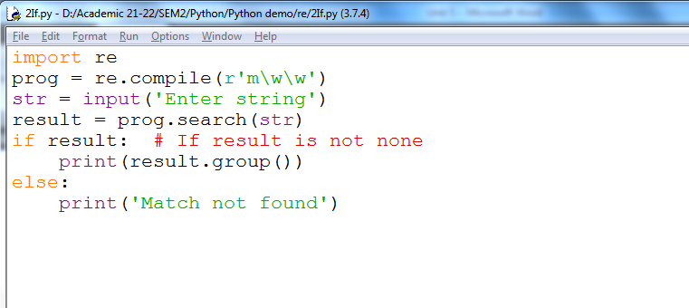
Output:

Program: A Python program to create a regular expression to search for strings starting with m and having total 3 characters using the findall().
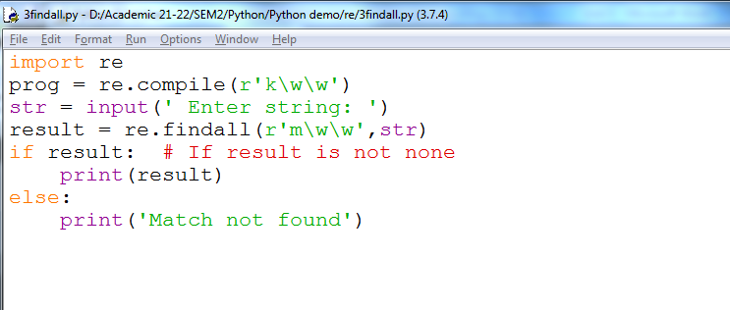
Out put
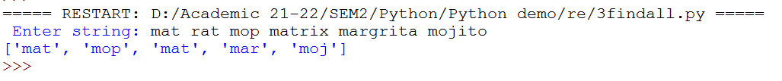
Here, you can the above code in following way:
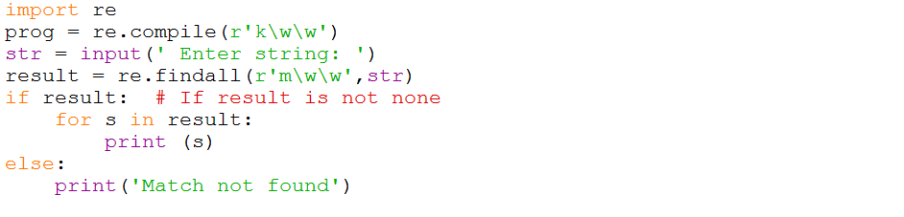
Output:
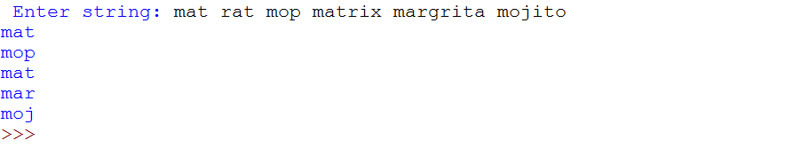
Match method (): There is another method by the name match () that returns the resultant string only if it is found in the beginning of the string. The match() method will give None if the string is not in the beginning. Consider the following program:
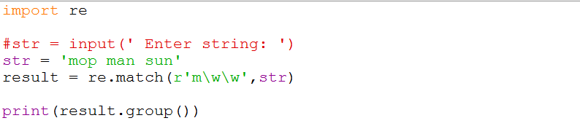
Output:

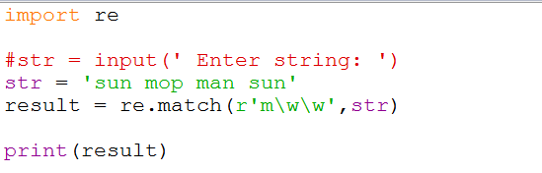
Output:
Split () method: This method splits the given string into pieces according to the regular expression and returns the pieces as elements of a list. Suppose we write a regular expression as:
re.split (r’\W+’, str)
Here, ‘\W’ (capital W)which is reverse to the small ‘w’.
‘W’ represents any character that is not alpha numeric. So, the work of this regular expression is to split the string ‘str’ at the places where there is no alpha numeric character. The ‘+’ sign after W represents to match 1 or more occurrences indicated by W. The result is that the string split into pieces where 1 or more non alpha numeric characters are found.
Program: A Python program to create a regular expression to split a string into pieces where one or more non alpha numeric characters are found.
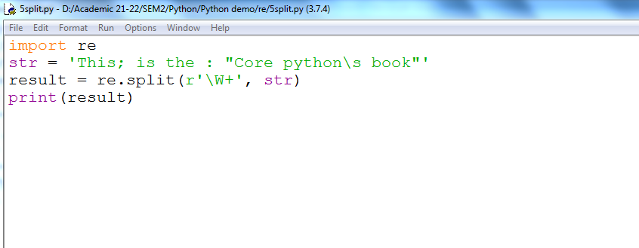
Output:
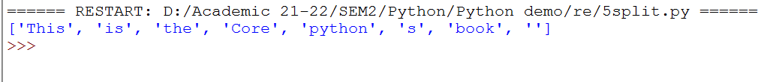

Sequence Characters in Regular Expression
Sequence characters match only one character in the string.
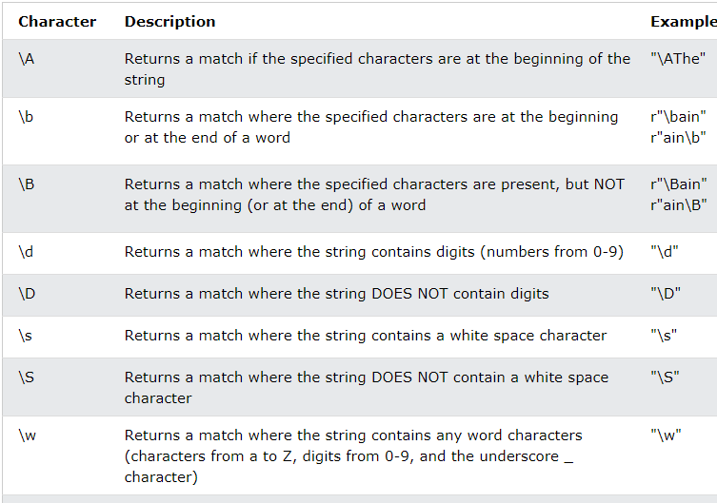
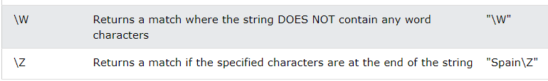
Each of these sequence characters represents a single character matched in the string. For example, ‘\w’ indicates any one alphanumeric character. Suppose we write it as [\w]*. Here, * represents 0 or more repetitions. Hence [\w]* represents 0 or more alphanumeric characters.
Program: A Python program to create a regular expression to retrieve all words starting with “a” in a given string.
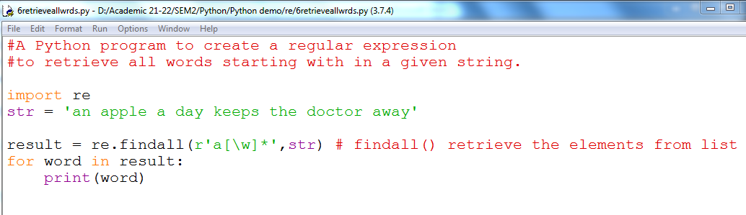
Output:
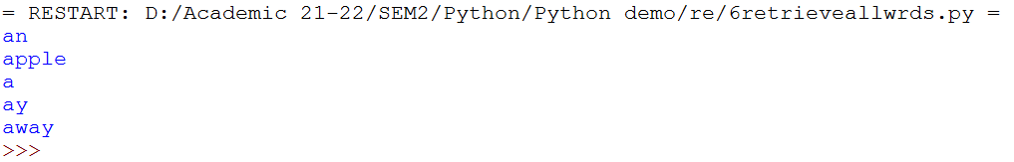
Here, we can see in output ‘ay’ is there which is not a word. This ‘ay’ is part of the word ‘away’. So, it is displaying both ‘ay’ and ‘away’ as they are starting with ‘a’. We do not like this. We want only the words starting with ‘a’. Since a word will have space in the beginning or ending, we can use ‘\b’ before and after the words in the regular expression. So the regex will become:
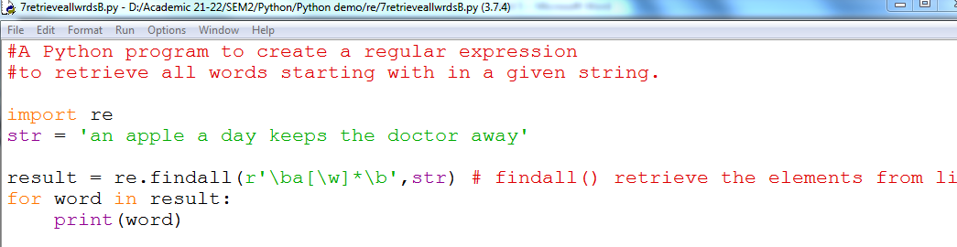
Output 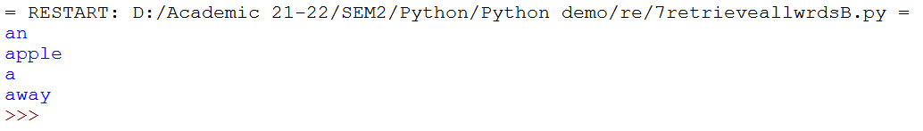
Program 8: A Python program to create a regular expression to retrieve all words starting with numeric digit.
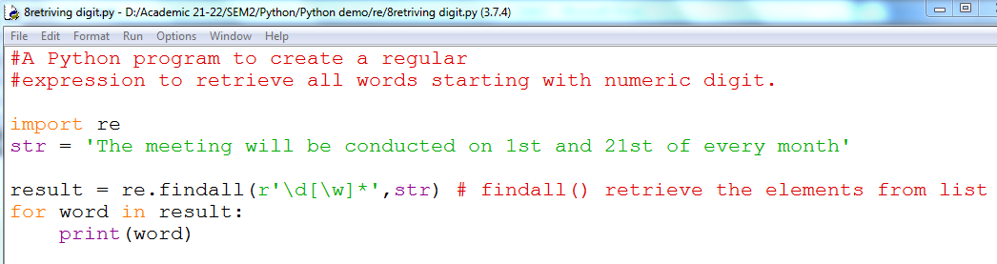
Output:
Program 9: A Python program to create a regular expression to retrieve all words having 5 character lengths.
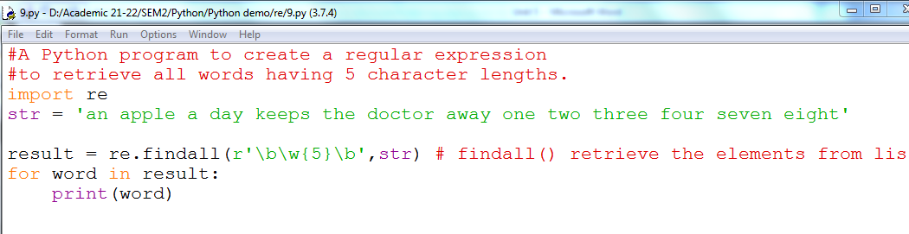
Output:
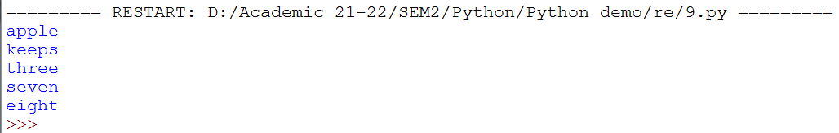
Program 10: A Python program to create a regular expression to retrieve all words having 5 characters length using search ().
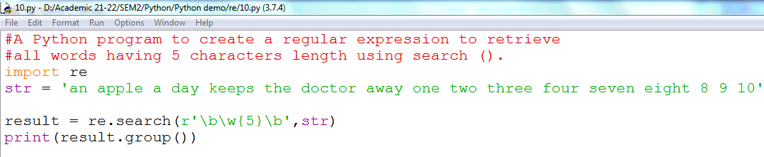
Output:
Now we will improve our search. Now, we want to find all words which are at least 4 characters long. That means words with 4, 5 or any number of characters will be retrieved.
Program11: A Python program to create a regular expression to retrieve all the words that are having length of at least 4 characters.
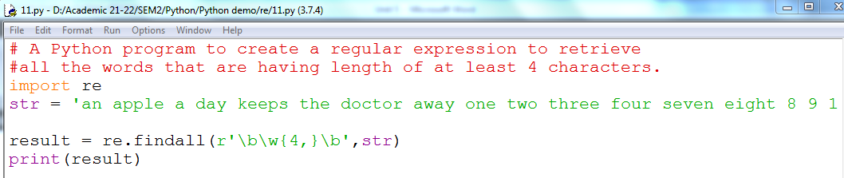
Output
Program 12: A Python program to create a regular expression to retrieve the last word of a string, if it starts with t.
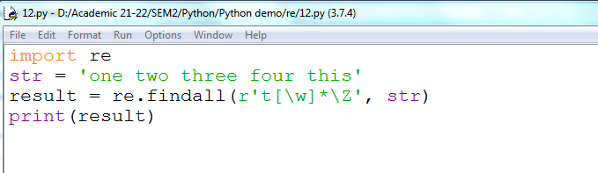
Output:

Quantifiers in Regular Expression
In regular expressions, some characters represent more than one character to be matched in the string. Such characters are called ‘quantifiers’. For example, if we write ‘+’ it represents 1 or more repetitions of the preceding characters. Hence, if we write an expression as r’\d+’, this indicates that all numeric digits which occur for 1 or more times should be extracted.
- * = This says the component must be present either zero or more times.
- + = This says the component must be present either one or more times.
- ? = This says the component must be present either zero or one time.
- {n} = This says the component must be present n times.
- {n, } = This says the component must be present at least n times.
- {n, m} = This says the component must be present at least n times and no more than m times.

Program 13: A Python program to create a regular expression to retrieve the phone number of a person.
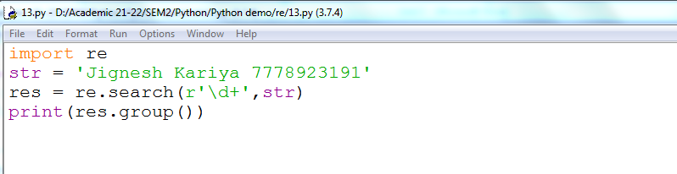
Output:
Program 14: A Python program to create a regular expression to extract only name but not number from a string.
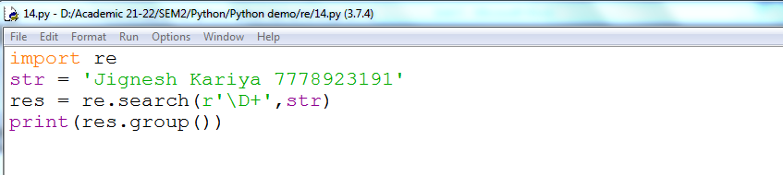
Output:
‘*’ represents 0 or more repetitions. Suppose we want to write a regular expression that finds all words starting with either ‘an’ or ‘ak’, then we can use: r’a[nk][\w]*’. Here, note that a [nk] represents either ‘n’ or ‘k’ or both.
Program 15: A Python program to create a regular expression to find all words starting with 'ak' or 'an'.
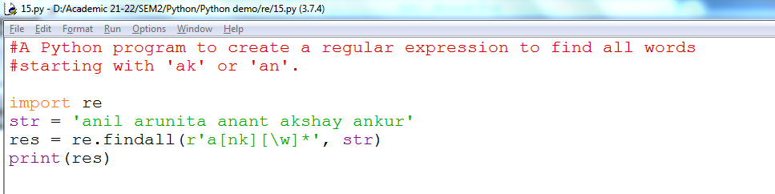
Output:

We know that {m, n} indicates m to n occurrences. Suppose we take ‘\d {1,3}’, it represents 1 to 3 occurrences of ‘\d’. Let’s see how to use this.
Program 16: A Python program to create a regular expression to retrieve date of births from a string.
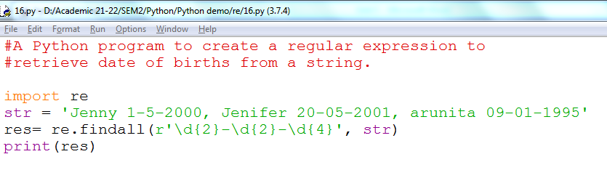
Output:
Here observe that the date of Jenny, i.e 1-5-2000 is not retrieved. So to do so we can rewrite the program as follows:
Program 17:
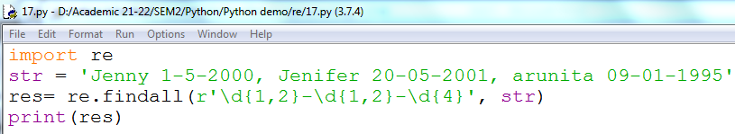
Output:
Special Characters in Regular Expression
Character | Description
\ | Escape special character nature.
. | Matches any character except new line.
^ | Matches beginning of a string.
$ | Matches ending of a string
[…] | Denotes a set of possible characters. Ex: [6b-d] matches any characters ‘6’, ‘b’, ‘c’ or ‘d’
[^…] | Matches every character except the ones inside brackets. Ex: [^a-c6] matches any character except ‘a’, ‘b’, ‘c’ or ‘6’.
(…) | Matches the regular expression inside the parentheses and the result can be captured.
R | S | Matches either regex R or regex S

The carat (^) symbol is useful to check if a string is starting with a sub string or not. For example, to know a string is starting with ‘He’ or not, we can write the expression: f”^He”.
Program 18: A Python program to create a regular expression to search whether a given string is starting with ‘He’ or not.
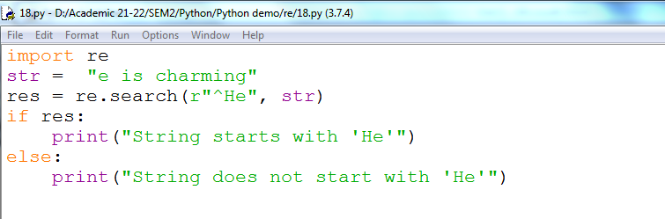
Output:
Program 19: A Python program to create a regular expression to search for a word at the ending of a string.
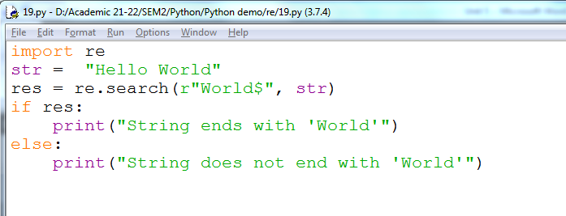
Output:
Regular expressions conduct a case sensitive searching for the strings.
We can specify a case insensitive matching of strings with the help of IGNORCASE constant or‘re’ module.
Program 20: A Python program to create a regular expression to search at the ending of a string by ignoring the case.

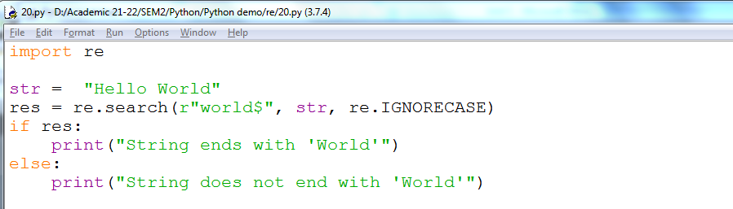
Output:
The square brackets [] in regex represent a set of characters. For example, if we write [ABC], it represents any one character A or B or C.
A hyphen (-) represents a range of characters. For example, [A-Z] represents any single character from the range of capital letters A to Z. Similarly, [a-z] represents any single lowercase letter. This is useful to retrieve names from string. For example, a name like ‘Jenifer’ starts with a capital letter and remaining are lower case letters. To search such strings, we can use a regular expression as: ‘[A-Z][ a-z]*’.
Program 21: A Python program to create a regular expression to retrieve marks and names from a given string.
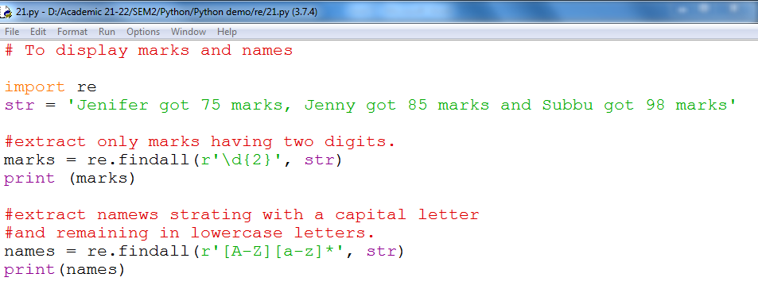
Output:
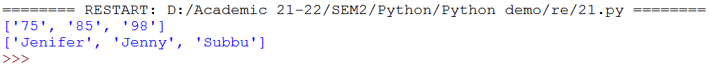
The pipe symbol (|) represents ‘or’. For example, if we write ‘am|pm’, it finds the strings which are either ‘am’ or ‘pm’.
Program 22: A Python program to create a regex to retrieve the timings either ‘am’ or ‘pm’.
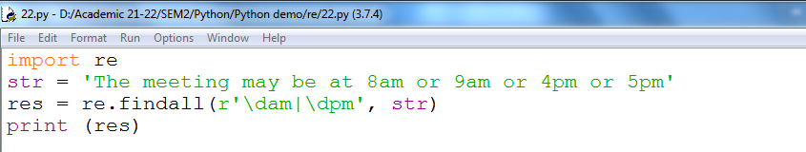
Output:
Using Regular Expression on Files
We can use regex on files where huge data is available. As we know, a file contains a lot of strings. We can open the file and conduct searching or matching etc. operations on the strings of the file using regular expressions. For this purpose we should open the file as:
Now the data of the file is now referenced by the file object or file handle ‘f’. We can read line by line from the file object using a for loop as:

Program 23: A Python program to create a regex that reads email-ids from a text file.
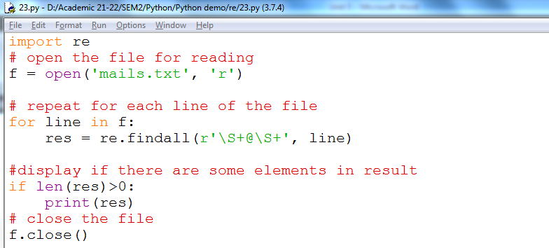
Output:
Program 24: A Python to retrieve data from a file using regex and then write that data into a file.
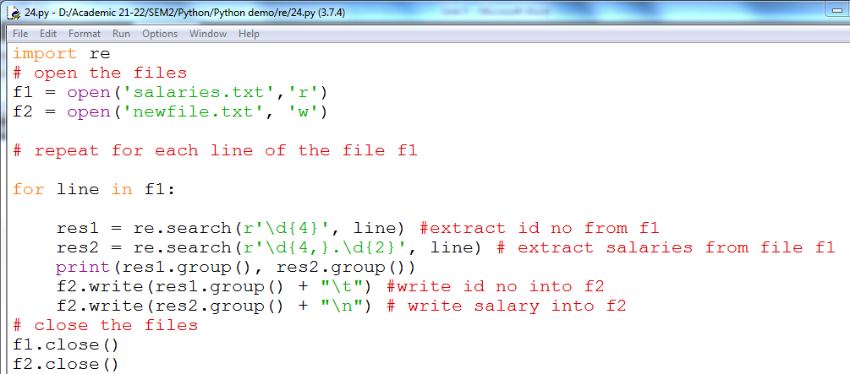
Output:
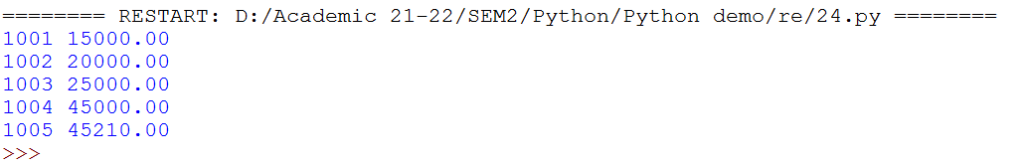
Retrieving Information from a HTML File
Let’s see how to apply regular expressions on a HTML file and retrieve the necessary information. As an example, let’s take a HTML file that contains some items for breakfast and their prices in the form of a table, as shown here:
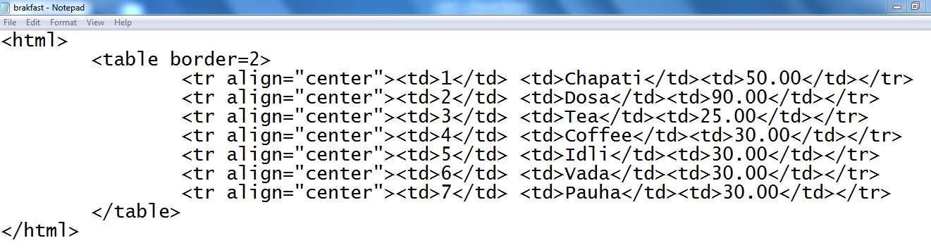
When we open this file , we can see the table in the browser where the values of item number, item name and price are displayed. 